Breaking things down

|  |  |
| --- | --- |
| Functional (procedural) programming | Object-oriented programming |
| * Break programs down into functions that perform some operation | * Break programs down into classes that give behavior to some kind of data |

Beginning of this unit:

* These two forms of decomposition are so exactly opposite that they are two ways of looking at the same “matrix”
* Which form is “better” is somewhat personal taste, but also depends on how you expect to change/extend software
* For some operations over two (multiple) arguments, functions and pattern-matching are straightforward, but with OOP we can do it with double dispatch (multiple dispatch)

The expression example

Well-known and compelling example of a common pattern:

* **Expression** for a small language
* Different **variants** of expressions: ints, additions, negations, …
* Different **operations** to perform: eval, toString, hasZero

Leads to a matrix (2D-grid of variants and operations

* Implementation will involve deciding what “should happen” for each entry in the grid regardless of PL

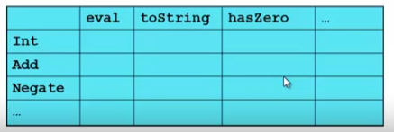

**Standard approach in ML**

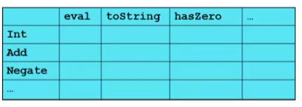

* Define a *datatype*, with one *constructor* for each variant
  + (No need to indicate datatypes if dynamically typed)
* ‘Fill out the grid’ via **one function per column**
  + Each function has one branch for each column entry
  + Can combine cases (e.g., with wildcard patterns) if multiple entries in column are the same

**Standard approach in OOP**

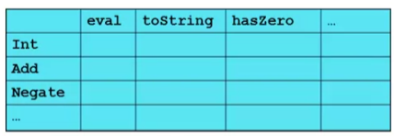

* Define a *class*, with one *abstract* method for each operation
  + (No need to indicate datatypes if dynamically typed)
* Define a *subclass* for each variant
* So “fill out the grid” via **one class per row** with one method implementation for each grid position
  + Can use a method in the superclass if there is a default for multiple entries in a column

A big course punchline

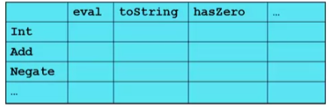

* FP and OOP often doing the same thing in exact opposite way
  + FP
    - Organize the program by columns
  + OOP
    - Organize the program by rows
* Which is “most natural” may depend on what you are doing (e.g., an interpreter vs. a GUI) or personal taste
* Code layout is important, but there is no perfect way since software has many dimensions of structure
  + Tools, IDEs can help with multiple “views” (e.g., rows/columns)